ITW1
PYTHON ASSIGNMENT 5


Pacha Venkata Sri Harsha
20075063
4 Year B. Tech
Computer Science and Engg.
PROBLEM 1
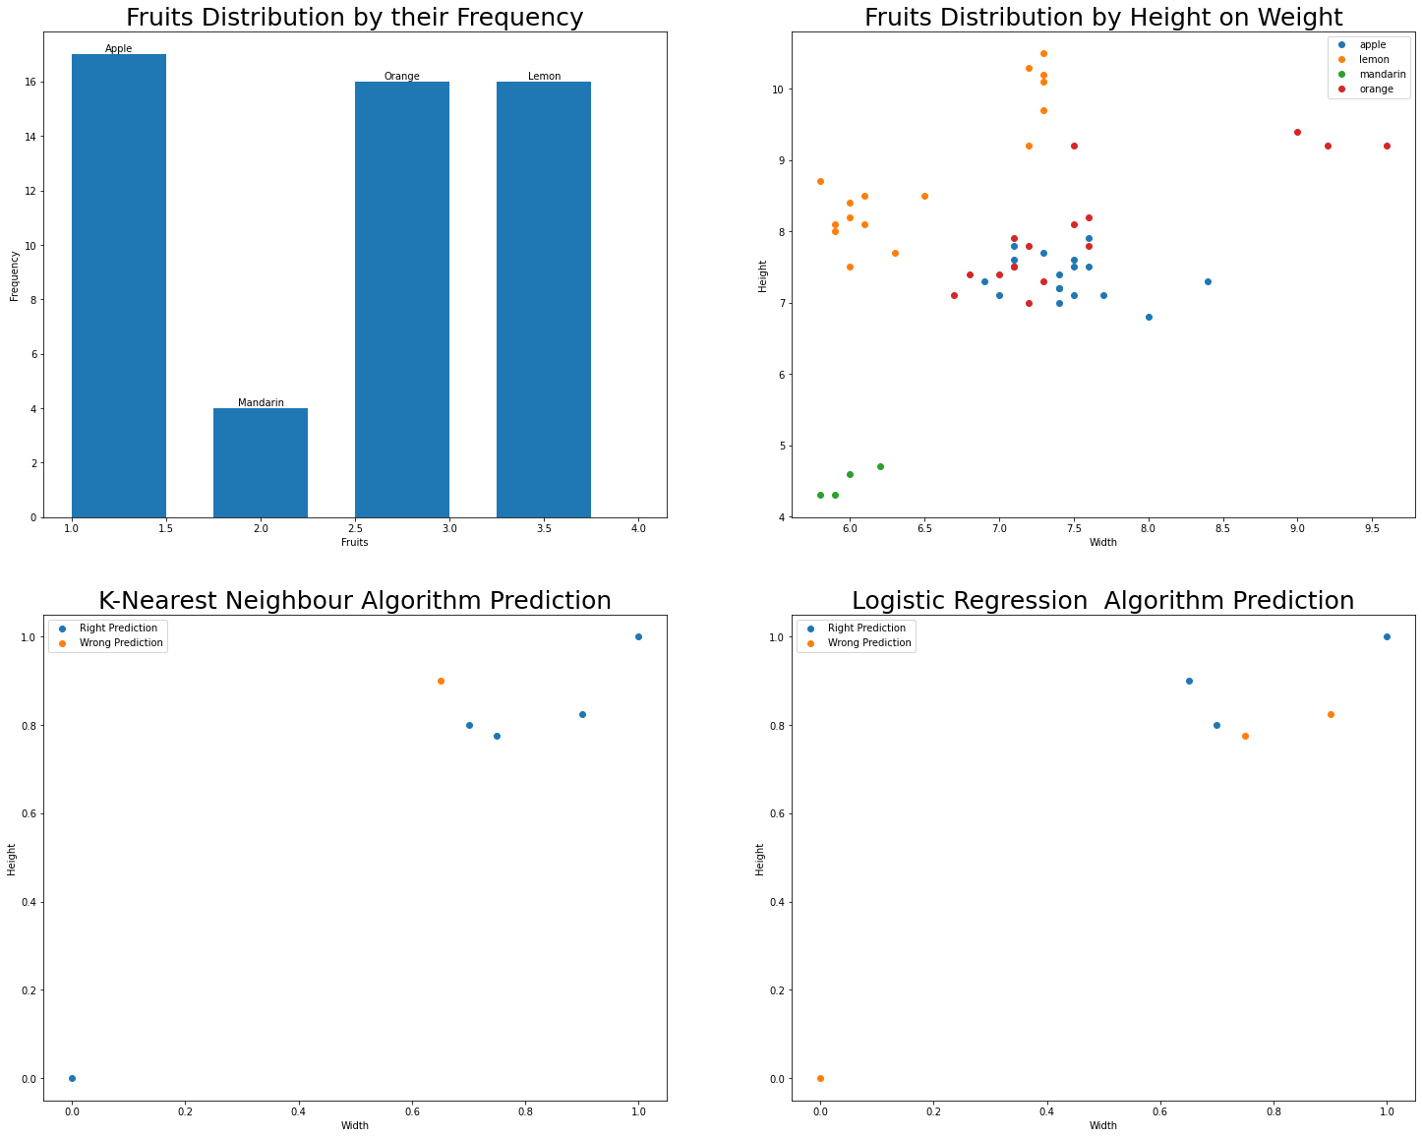
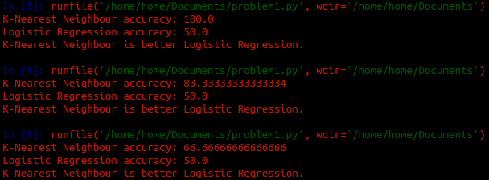
Every Time, its showing that K-Nearest Neighbour Algorithm is better than Logistic Regression Algorithm.
PROBLEM 2
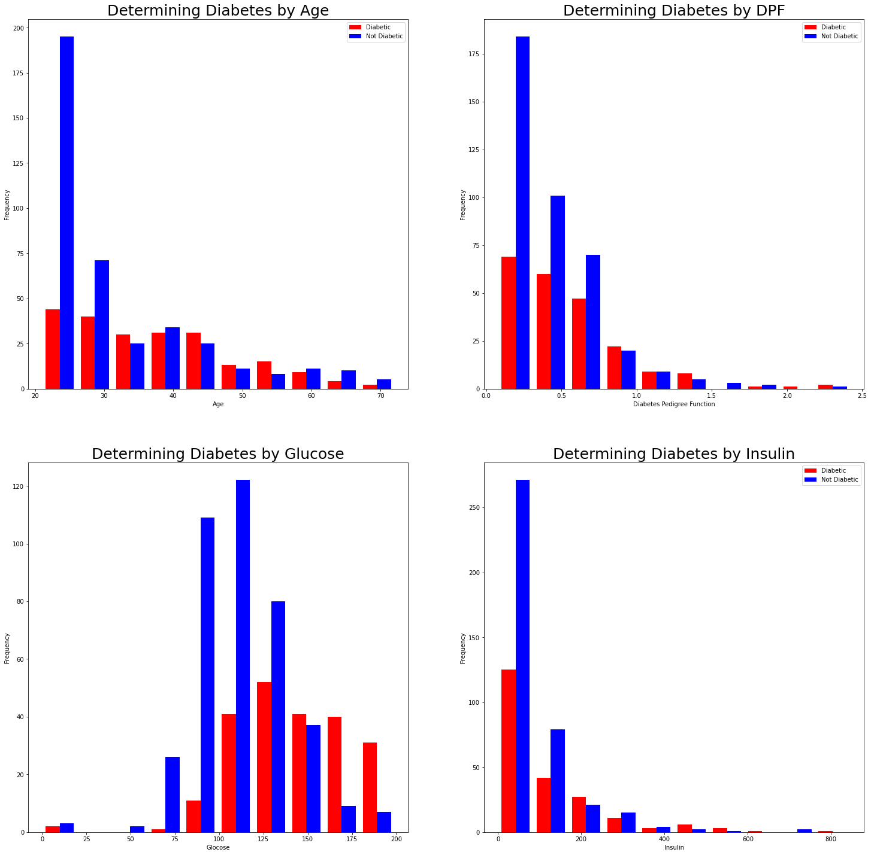

Predicting the chance of having diabetes by various features.
Some More Features...
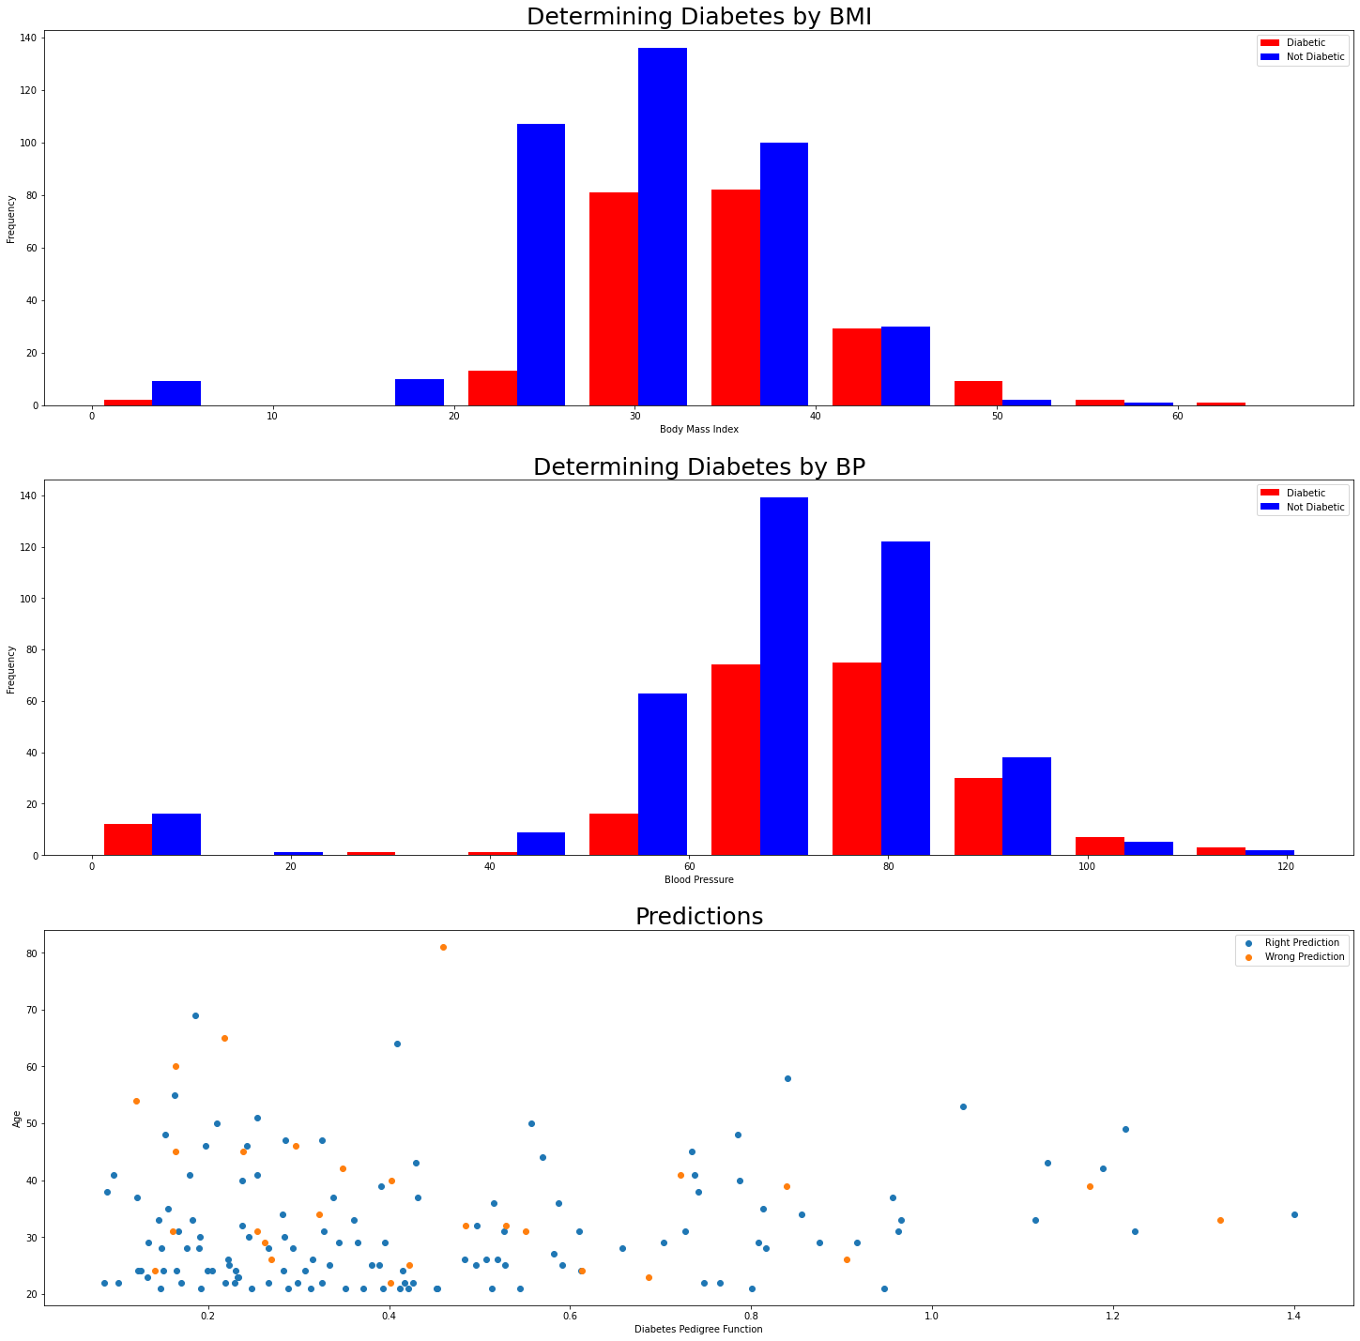
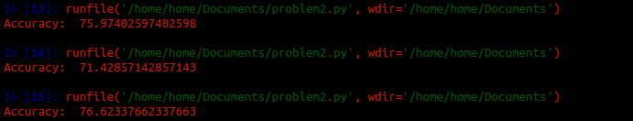
Accuracy:
PROBLEM 3
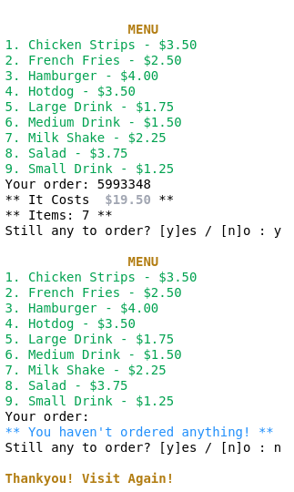

PROBLEM 4

1. Adding a contact
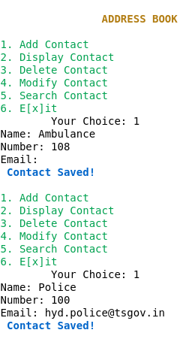
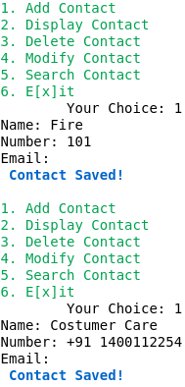

Here 4 contacts have been added.

2. Displaying a Contact
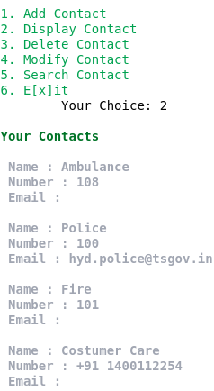

3. Deleting a Contact
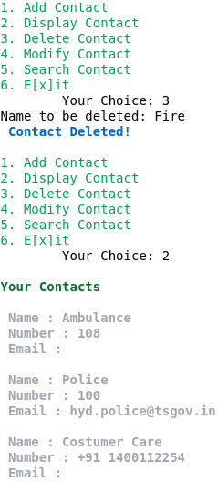

4. Modifying a Contact
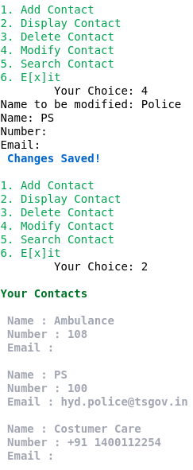

5. Searching a contact
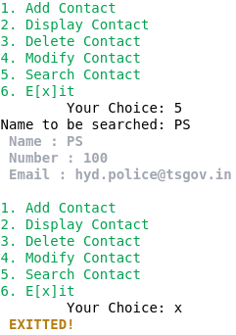

----------------END OF PDF FILE---------------

